(Approx. 1046 words)

Android Apps on Windows 11 – Well, I’ll be!
By Phil Sorrentino, Secretary and APCUG Rep, Sun City Center Computer Club
https://scccomputerclub.org/
philsorr (at) yahoo.com
Many apps that run on Android smartphones and tablets may soon be running on Windows 11 machines. As of February 2022, only in the US are Android apps available for Windows. A new addition to Windows 11, “Windows Subsystem for Android,” will enable your Windows 11 device to run Android applications that are available in the Amazon App store. That may sound a bit confusing since Apps for Windows usually come from the Microsoft store. Be that as it may, this feature may eventually prove useful.
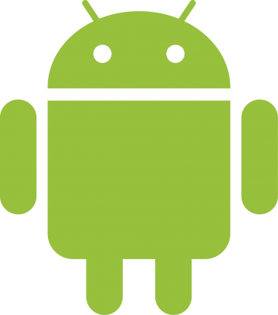 On 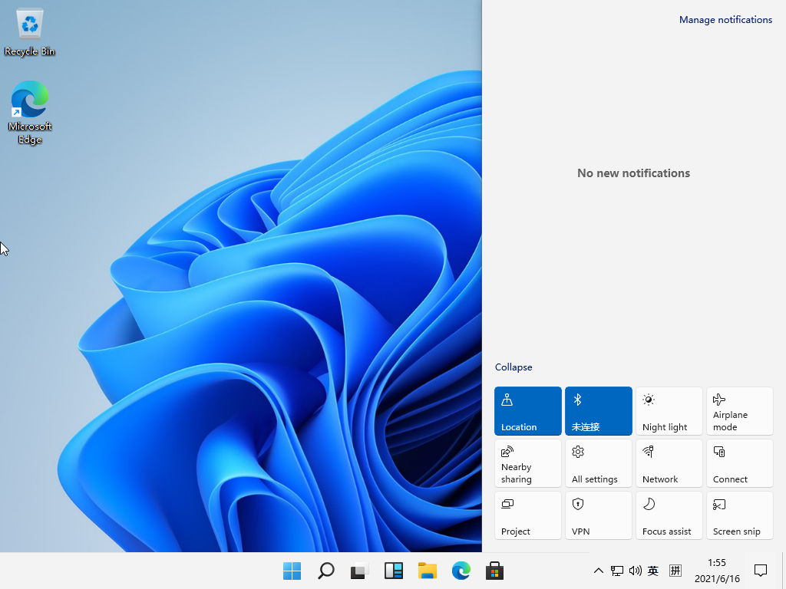
If your computer meets the requirements for Windows 11, it meets the requirements for Android Apps. (Make sure to check for any Windows 11 updates, and install them before proceeding with Android Apps.) Additionally, Windows 11 must-have hardware virtualization enabled. Windows 11 essentially runs Android in a virtual machine, which is why this is necessary. (A Virtual Machine is a computer image-based software that can run programs and Apps.)
To check if your computer has virtualization enabled, go to the “Performance” tab in Task Manager (Ctrl+Shift+Esc). Then, open Task Manager, and click “More details” if you don’t see the Performance information. If virtualization is not enabled for a computer using an Intel CPU, you can enable Intel VT-X in your computer’s UEFI firmware (BIOS). If your system uses an AMD CPU, look for AMD-V in the UEFI firmware settings.) Four of the six computers that I checked had virtualization enabled.
If you are part of the Windows Insider Program, you may have already experienced Android apps for those more technically inclined. So far, the Windows Insider Program has been testing the capability with fifty or so popular Android Apps. Eventually, you will see the “mobile” Apps in the “new” Microsoft store, though currently, the download will come from the Amazon App store. Articles in the literature indicate that once downloaded, you can run these apps side-by-side with the help of the new Snap Layouts feature of Windows 11. And you’ll be able to pin them to your Start menu or Taskbar and interact with them via a mouse, a touch screen, or an input pen. Also, you will be able to share your clipboard between Windows and Android Apps, and you will be able to see notifications from Android Apps in the Windows Notification Center, which sounds like a pretty comprehensive integration into the Windows 11 environment. Why would you need a mobile App when you have plenty of Apps on your desktop computer? Well, there may be some mobile Apps that don’t have a desktop equivalent. Early results of the Windows Insider Program highlighted a few areas that may be interesting, such as Games, Reading books with Kindle, and content for kids, such as teaching math, reading, and writing skills. The Windows Insider Program encourages developers and creators to develop Apps for this new Windows 11 environment.
For those of you who would “lean in” to a technical discussion, this paragraph is for you; others might want to skip this paragraph. Just a little “techno-talk,” Windows 11 will soon be enhanced by adding a new component. This new component will be a subsystem that will essentially ride on top of Windows 11 and will be called the “Windows Subsystem for Android.” The subsystem will include the Linux kernel and an Android OS based on the Android Open Source Project version 11. It will be distributed through the Microsoft Store as part of the Amazon App store installation, allowing users to stay updated over time as the software evolves. The subsystem runs in a Hyper-V Virtual machine, allowing multiple Operating Systems to run simultaneously. End of ‘techno-talk,” suffice to say it will be a relatively sophisticated and complex software product. For example, one of the icons for Android on Windows looks like this:
So, for those who might be more adventurous, how do you install Android Apps on a Windows 11 computer? As always, there are YouTube videos on the subject which would be an excellent first step. After the videos, the first thing to do is open the Microsoft Store on your computer. Click the start button, find the Microsoft Store in the alphabetical Start Menu list, and click it to open it. In the App Store, search for Amazon App Store”. If the Amazon App Store is not installed, you will have to install it. (Note that this could take a while. A pop-up will appear and guide you through the process; click “Set up” and continue through the steps down to the App Store installation. The last thing to do will be a computer restart. After the restart, the Amazon App Store will automatically open. If it doesn’t, you should find it in the Start Menu.) When installed, the first thing to do is to sign into your Amazon account if you have one. If you don’t have an Amazon account, you can create one at this point. Once you are in the Amazon App Store, you will see that it works like all the other App stores you have used. (When I first installed the Amazon App store, I didn’t find any App that I needed, but that was expected because, at that time, there was a limited number of Apps available, though we are told that many Apps are soon to come.) In the store, you will find free and not-free Apps. The free Apps will have a “Get” button; the not-free apps will have a button with a price. Navigate to an App you want and click the appropriate button. Click Install, and the App will download and then install. You can click “Open” to use the App when the installation is finished.

If you followed the directions and everything worked out, you have just installed your first Android App on a Windows device. The Android apps you downloaded can now be found in the Start Menu, just like Windows Apps. They can even be pinned to the Taskbar like regular Windows apps. But what about Android Apps that are unavailable in the Amazon App Store? Well, you can always “sideload” Apps, but that’s a subject for another time.

